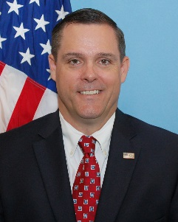

shaun.oneill@gdit.com

Shaun recently joined the Healthcare Fraud Prevention Partnership as a Partner Liaison after a 23-year career in law enforcement working criminal matters for the FBI to include white collar crime, narcotics, public corruption and organized crime. Shaun is the co-founder of the Greater Palm Beach Health Care Fraud Task Force. Prior to his bureau retirement, he spent five years supervising a squad of Agents and Analysts that investigated health care fraud, human trafficking, public corruption and civil rights. Shaun served as the Human Trafficking Program Coordinator for the Miami Division for three years.

In 2008, he was the recipient the Attorney General’s Distinguished Service Award, Department of Justice’s second highest award, for his work creating the Medicare Strike Force prosecution model. In 2015, he was the recipient of the Attorney General’s Award for Fraud Prevention for Operation Sledgehammer, an investigation into Chiropractic/PIP fraud in Palm Beach County. In 2017, Shaun was the recipient of the National Health Care Anti-Fraud Association Investigation of the Year award for his work on the sober home fraud epidemic (United States v. Kenneth Chatman).

Shaun holds a Bachelors Degree in Economics and is a Certified Public Accountant. He holds the designations of Certified Fraud Examiner and is Certified in Financial Forensics by the American Institute of Certified Public Accountants. He also maintains a Top Secret Security clearance. He has been a speaker on various health care fraud and human trafficking topics at national conferences. He lives in Jupiter, Florida with his wife and two children where he enjoys golfing, boating and coaching lacrosse.

